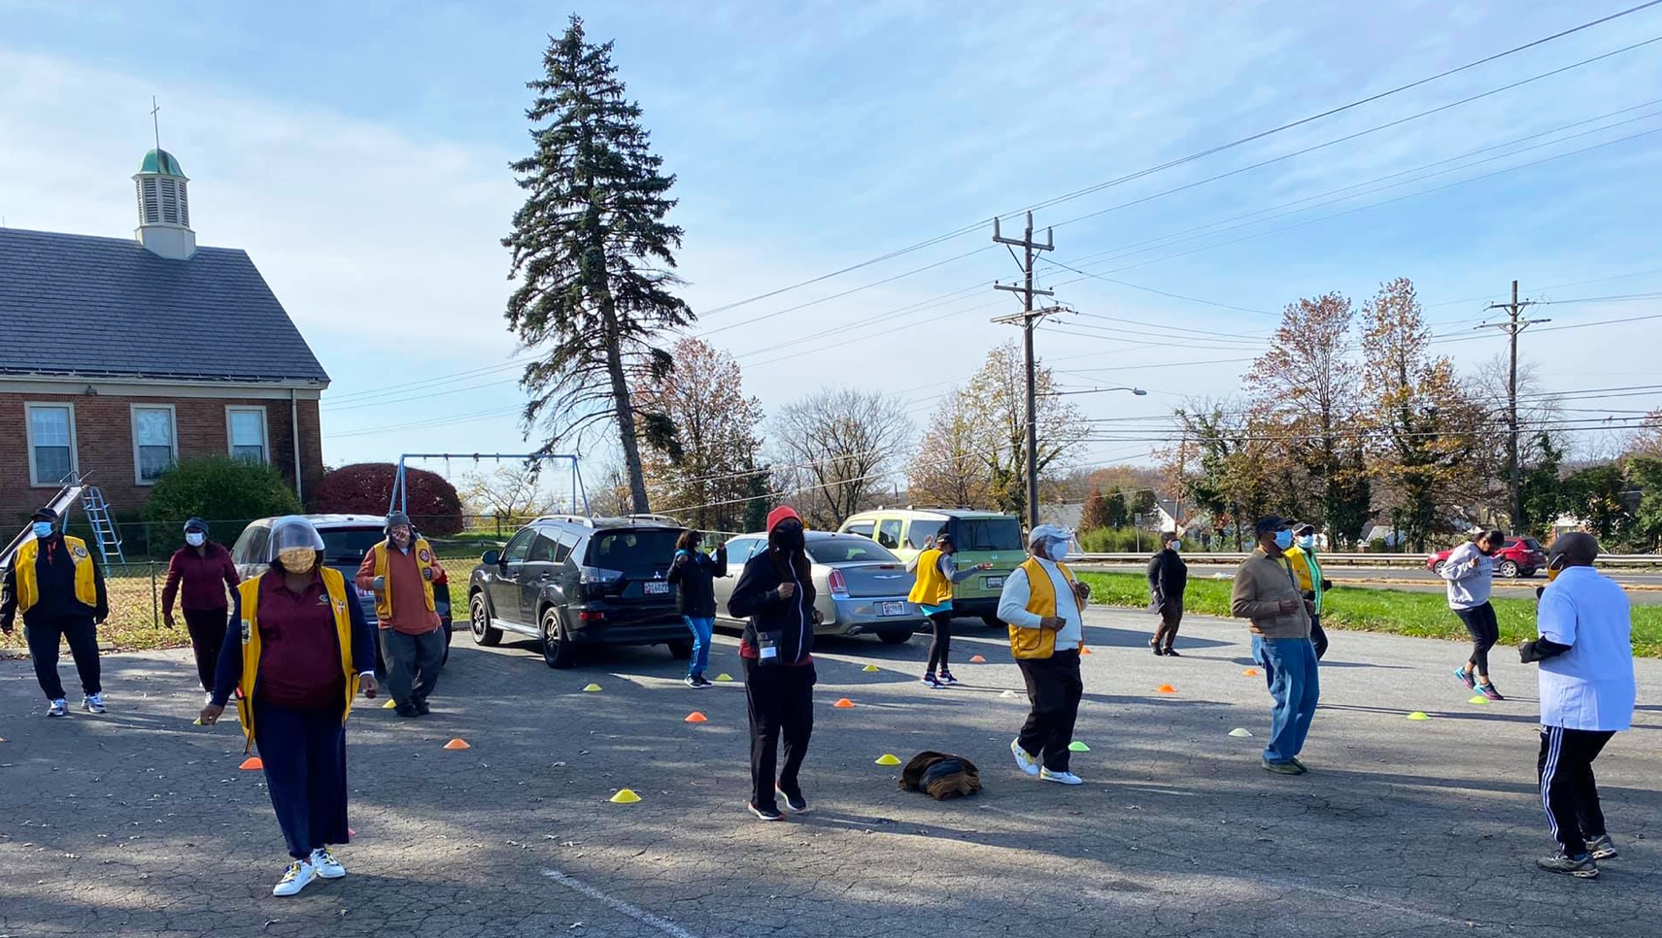
County residents participate in a socially distant exercise session at World Diabetes Day on November 14

AAHP MONTHLY REPORT

November 2020

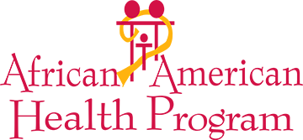

African American Health Program
November 2020

INTRODUCTION
As November recorded an unprecedented surge in COVID-19 cases across the country as well as in Montgomery County, the African American Health Program (AAHP) continued implementing the fifth year of the contract between McFarland and Associates and the Montgomery County Department of Health and Human Services (DHHS) to reduce health disparities and individual and family health risks to Montgomery county residents of African descent by providing outstanding public health programs and services. AAHP offered health promotion, prevention, and wellness services to County residents using social media, teleconferencing technology, videos, and even in-person engagements (following Centers for Disease Control and Prevention (CDC) and health department recommended safety precautions and protocols that included social distancing and donning personal protective equipment such as masks, gloves, and face shields. Thus far, not a single case of COVID-19 infection has been reported among AAHP staff, and now that several biopharmaceutical companies have announced high efficacy in their COVID-19 vaccines, there is a reason for the hope that more County residents will be spared as well).

The month also marked an important transition and milestone for the African American Health Program. Dr. Ikenna Myers, who led the Chronic Disease Management Program (CDMP), assumed a new role within the AAHP family as Program Manager within DHHS in November. AAHP is grateful for his significant contribution to the success of the program and wishes him well while also welcoming our new CDMP instructor, Dr. Nancie Richberg.

In an important milestone, the AAHP Executive Committee began sponsoring COVID-19 testing sites. Individuals receiving tests at the AAHP Executive Committee sites received a touchless thermometer, a box of masks, soap, and hand sanitizer. It is recommended that healthcare professionals or anyone who is working out in the community get tested regularly. Participants are emailed their results in 3–5 days.

On Saturday, November 7, AAHP, in collaboration with Kappa Alpha Psi, Gaithersburg-Rockville Chapter, held a 3-hour Brother2Brother virtual health symposium to raise awareness about the health concerns of Black men in Montgomery County and provide them with resources to address some of those concerns. The plenary session was devoted entirely to AAHP with equal time for AAHP’s clinical director, AAHP’s oral health consultant, and AAHP’s CDMP instructor. The AAHP team offered presentations on the overall health status of Black men in Montgomery County and strategies for maintaining good oral pharyngeal hygiene to counter the spread of the coronavirus and prevent diabetes. During four breakout sessions, other presenters covered good nutrition, mental health, veterans’ health, and stress reduction. All 42 participants stayed for the duration of the symposium.

Despite cooling temperatures, AAHP continued to engage County residents at Grab & Go food distribution events throughout the County, including The People’s Community Baptist Church, Kings & Priest Church, Kingdom Fellowship, and East County Recreation Center. At these encounters, staff handed out food and information about COVID-19 safety protocols and state health insurance, collected contact information for the case management system, and recommended AAHP programs, other minority health initiatives, and ways to access other County resources. As always, AAHP’s focus is on assisting residents of African descent, so as a result of interactions at these events, most of the referrals were to AAHP programs such as the CDMP, dMeetings, remote patient monitoring (RPM), and weight management programs. No residents were turned away, however, and many referrals were made to the Latino Health Initiative and other County support programs. Staff is also encouraging individuals to obtain flu shots and COVID-19 tests in preparation for the winter season.

During November, every SMILE client received one or more telehealth visits. To observe social distancing while also communicating with and educating County residents, the staff continued to refine and further expand the use of virtual communication technology, especially Zoom, Teams, FaceTime, Skype, and Duo. SMILE nurses used these technologies to conduct virtual visits to clients and their families and other providers. Virtual communications allowed staff to communicate with more participants and to provide advice, education, information, and counseling on how to stay healthy and prevent the spread of COVID-19. Many of these visits also included encounters with AAHP’s social worker and community health workers who collaborated to bring the best quality and range of services to pregnant and postpartum mothers. As the pandemic persists, the range of social issues facing pregnant mothers and their families continues to increase.

The physical HIV screenings resumed in August 2020 and continued in November. AAHP staff screened homeless and other residents for HIV, hypertension, glucose, and HbA1c. These screenings were conducted at the Men’s Homeless Shelter in Rockville, the Progress Place Homeless Shelter, and the Dennis Avenue Infectious Disease Clinic operated by DHHS.

During November AAHP staff also continued to apply lessons learned over the last nine months to refine the engagement process at the County’s food distribution program events, which continue to provide significant opportunities to connect with County residents at distribution sites in East County, particularly The People’s Community Baptist Church, White Oak Gardens Apartments, Kings & Priests International Church, and Windsor Court Apartments. Grab & Go encounter data is now being tracked in several categories.

In November, the SMILE staff continued to increase the number of educational webinars and a library of videos on improving pregnancy and postpartum outcomes for Black mothers and their infants. Since the beginning of the COVID-19 pandemic, the AAHP staff has improved their aptitude at producing high-quality videos that are culturally appropriate on a diverse range of health-related issues that can be stored on the AAHP website, posted on social media, and made easily accessible for future use.

AAHP PROGRAM ACTIVITIES

SMILE PROGRAM (Start More Infants Living Equally healthy)
The efforts deployed by the entire AAHP staff to raise awareness about the SMILE program have begun to yield results by delivering in November the best performance of the program in the fiscal year 2021. This represents the second consecutive increase in the caseload which reached 137 in November and included 55 infants and 82 mothers. Among the 82 mothers, 27 cases were prenatal, and 55 cases were postpartum. Three babies were born into the program in November. Regrettably, one was delivered by C-section at 32 weeks, weighing 2lbs and 3oz, and was placed in the neonatal intensive care unit. The other two were born healthy and at a normal weight. The nurses arranged for the distribution of car seats and cribs for the three new moms. Five new prenatal moms were enrolled. Six moms were discharged and one of the women said she wasn’t ready to leave and may have to have another baby to stay in the program.

At the end of November, 14 of the 82 mothers were classified high-risk cases because of medical issues, 10 cases classified as high-risk social issues, and 7 cases presented with both high medical and social risks. High-risk medical conditions included gestational diabetes, pre-eclampsia, a history of multiple miscarriages, and advanced maternal age. Six new prenatal cases and two postpartum moms were screened for depression using the Edinburgh Postnatal Depression Scale. As a result of the screening, three mothers scored above the normal range and were referred for further evaluation and care. As in previous months, frequently cited social needs including housing, help with utility bills, transportation to medical appointments, food insecurity, and concerns about personal safety. Social risks included low self-esteem, unemployment, low educational attainment, unclear immigration status, language barriers, and inadequate family support. Staff addressed these issues through appropriate referrals. Other emotional health-related issues included providing emotional support and stress management counseling for SMILE clients experiencing anxiety and stress due to feelings of isolation and disconnectedness.

At the end of November, the overall percentage of mothers breastfeeding was 75%, and the percentage of mothers breastfeeding up to six months was 76%. Both breastfeeding indicators match or exceed the national rates reported by the CDC. Comparative data presented by the CDC shows that the percentage of African American women who ever breastfed was 64.3%, and of that number, only 20% breastfed exclusively for six months after delivery. As shown in the graph presented below, the ethnic representation of mothers participating in the SMILE program showed 67% African, 32% Black American, and 13% Caribbean.

During November, the nurses held weekly meetings. These meetings were used to review individual cases and to plan for comprehensive home visits and staffing and included in-depth reviews of difficult cases in consultation with the AAHP social worker, the nurse supervisor, and the clinical director. All SMILE nurses attended the Fetal Infant Mortality Review Community Action Team (FIMR-CAT) webinar on November 17th.

The SMILE nurse case managers also conducted outreach to attract more Black moms to the program. One nurse is working through her church women’s and music ministries as well as training on the use of LinkedIn to implement a strategic referral outreach strategy.

On November 20th, a SMILE nurse conducted a webinar on Childbirth and Recovery and another SMILE nurse offered a webinar on Preconception Health on November 24th. Participants found the sessions informative and links to the videos of the sessions were emailed to mothers who could not attend.

AAHP’s French-speaking nurse had a total of 15 SMILE Zoom visits in November to help the other nurses' bridge language barriers and helped a client complete Medicaid, WIC, and Rental Assistance applications.

The table and charts below present an overview of the SMILE cumulative data for November 2020 as compared to the performance in the calendar year 2019.

 | PROFILES AND SERVICES | *Monthly  Average of Reference Calendar Year  2019 | November  2020 | Comments
1 | CURRENTLY ACTIVE MOMS | 88 | 82
2 | Prenatal (still pregnant) | 30 | 27
3 | Postpartum  (Moms who have delivered) | 57 | 55
4 | ALL INFANTS | 57 | 55
5 | Single Births | 53 | 55
6 | Multiples | 4 | 0
7 | Case Load (A+B) | 147 | 137
 | MOM’S ETHNICITY
8 | African American Clients | 39 | 26
9 | African Clients | 46 | 55
10 | Caribbean Clients | 3 | 1
 | REFERRALS
11 | HHS Prenatal Referrals Received | 7 | 4
12 | Referrals from Other Sources | 4 | 1
13 | Total Prenatal Referrals | 11 | 5
 | NEW ENROLLMENTS
14 | Prenatal Moms newly enrolled during the Month | 8 | 5
15 | Infants newly enrolled during the month | 5 | 3
16 | All new enrollments for the month | 13 | 8
 | DISCHARGES during the month
16 | Prenatal Discharges | 1 | 0
17 | Infant Discharges | 5 | 3
18 | Total Discharges | 6 | 3
DELIVERIES
during the month
19 | Term Deliveries | 5 | 2
20 | Preterm Deliveries | 1 | 1 | Baby born at 32 weeks
21 | Total Deliveries | 6 | 3

 | BIRTH OUTCOMES
22 | % Healthy Birth Weight  (% of Total Deliveries) | 95% | 75%
23 | Number of  Low Birth Weight | 0 | 0
24 | Number of  Very Low Birth Weight | 0 | 1
25 | Infant Deaths  (includes Stillbirths) | 0 | 0
26 | Unfavorable Birth Outcomes  (Congenital Anomaly, Fetal Demise, Miscarriage) | 0 | 0
 | SERVICES
27 | Total Home Visits | 78 | 1
28 | Telephonic Consultations | 8 | 184
29 | Community Referrals Made | 15 | 27
30 | Classes/Presentations Completed | 4 | 6
 | BREASTFEEDING MOMS
31 | Percent Clients Breastfeeding Infants  0-3 months | 92% | 79%
32 | Overall Breastfeeding Percent | 73% | 75%
 | INSURANCE
33 | Clients with Private Insurance** | 24 | 17
34 | Clients with Medicaid Insurance** | 62 | 64
35 | Clients without Insurance | n/a | 0

Key
*Averages are rounded up to the next integer
** A client may have multiple insurances
Increase above reference year
Level with reference year
The decrease from reference year
Untoward Outcome
Desired Outcome

The Chronic Disease Management Program (CDMP)

Virtual Health Education Webinars
The CDMP team continued its virtual webinar curriculum, within the three domains of public health education, plant-based nutrition, and chronic disease management, by offering four classes weekly in November. These classes on different evidence-based topics help participants improve their overall health and/or management of chronic disease. In November, the focus was on Diabetes in recognition of National Diabetes Awareness Month. The webinars included a combination of health education presentations and documentaries. The online classes presented information on how diabetes can be controlled through four healthy lifestyle behaviors: evidence-based health education, proper exercise, a plant-based diet, and stress reduction. The average number of participants increased in each class, in general, with Thursday's nutrition class topping the list. The CDMP team worked especially hard to ensure a smooth hand-off from the former CDMP instructor to the new one.

Kick Start Your Health (KSYH) I & II highlighted evidence-based health education during the Wednesday and Thursday evenings’ series. Wednesday’s series featured health education lectures on the physiology, prevention, management, and treatment of diabetes by the CDMP instructor. The Thursday evening series focused on gestational diabetes, the impact of diabetes on Alzheimer’s Disease and dementia, and the role of fitness and different types of exercise in reducing the risk of diabetes. Also, participants were able to take part in a stress management education session by AAHP’s social worker and mental health professional, which focused on reducing stress to mitigate the increased risk of diabetes due to chronic stress.

The CDMP Health and Nutrition and Health and Fitness classes focused on the plant-based diet and cooking demonstrations by AAHP’s Food for Life Instructor. The CDMP Health and Fitness component provided stress management and exercise through yoga and Zumba classes. The Zumba classes every Tuesday morning has been instrumental in helping participants get their 30 minutes of daily aerobic exercise recommended by the U.S. Department of Health and Human Services as part of the Physical Activity Guidelines for Americans. The yoga classes taught how fitness can prevent, manage, and reverse the risk for chronic diseases such as obesity, diabetes, hypertension, cancer, and Alzheimer’s disease. The classes included stretching and strengthening techniques and range of motion exercises adapted for multiple ages. The class incorporates traditions from both the Western culture of active movements and meditation from Asian cultures, in addition to teaching participants introductory yoga poses.

Throughout November, AAHP staff continued to establish partnerships to provide the best public health programming to CDMP class participants. On Thursday, November 19th, the University of Maryland College Park Kidney Disease Screening and Awareness Program presented a Kidney Health Workshop in partnership with AAHP. The presentation was interactive and included a wealth of important information about chronic kidney disease, risk factors, and necessary steps for prevention. Also, AAHP partnered with the Barnard Medical Center group to produce educational videos and live cooking demos, and to share their portal of resources (which are now used for client education package) and with a former CDMP program participant, who serves as the Community Life Senior Program Manager for Montgomery Housing Partnership (MHP) which serves more than 4,000 residents of Montgomery County and neighboring communities by providing more than 2,100 quality affordable homes. These partnerships are even more valuable during this pandemic where the stresses of housing and food insecurity disproportionately affected Black and brown communities.

The staff launched a new Support Group (after each class for 5 minutes or less) to welcome new members into the class and to answer any questions and direct them on the next steps which intended to allow more room to facilitate discussion, walk through the Chat features, resource navigation, outreach, referral, and data collection to ease communication and initiate follow up. Educational materials were shared via emails and zoom’s share screen feature and the chatbox; announcements were made, and class participants were encouraged to register for the next classes each week. A thank you note was sent out to all participants after class.

The core goals of the CDMP team continue to be leading participants towards adherence to self-monitoring and increasing the awareness of their ABC’s (Hemoglobin A1c, Blood Pressure, and Cholesterol) screening numbers. AAHP continues to encourage adherence to daily, weekly, and/or monthly self-monitoring in concert with their goals. AAHP also continues to distribute diabetes and hypertension self-management supplies to participants such as glucose meters, lancets, strips, and blood pressure monitors. Using the ‘Blood Glucose/Blood Pressure Monitoring Self-Management Agreement,’ CDMP staff have encouraged all participants to monitor their numbers using the self-monitoring devices and to relay those numbers to AAHP staff and their Primary Care Physician (PCP) during one-on-one consultations. To answer the remaining health-related questions, participants have the option of one-on-one consults with a nutritionist for medical nutrition therapy (MNT). During the sessions, participants can ask questions about their nutrition needs, receive a recommendation for changes in behaviors, and follow up with the nutritionist over the next month.

The AAHP CDMP team looks forward to December and providing evidence-based health education and encouraging lifestyle behavior change on topics including a focus on hypertension and heart health. AAHP will also launch the new AAHP Diabetes Prevention Program Prevent T2D Pre-diabetes classes on Tuesday evenings. These classes are a program sponsored and accredited by the CDC and based on a National Institutes of Health-funded study that examined the impact of diet and exercise on preventing people from developing diabetes. AAHP staff trained in the Prevent T2D curriculum via the Emory University/CDC-sponsored training will administer the 12-month long program. AAHP will continue to monitor the latest developments in the COVID-19 pandemic and educate participants and the community on healthy behaviors during these changing times and ways to mitigate risk to themselves and family members while still fostering cultures of good health within the home.

The charts below present the monthly statistics for CDMP classes in November 2020. The reporting format includes the following:
- The class and outreach activities coordinated
- The number of individuals/participants for class, duration of attendance, topics covered, and poll/quiz results
- The number of individuals/participants provided individual or group education.

CDMP CLASS Activities
ACTIVITY | HOURS | DATA REQUESTED | TOPIC COVERED
Health and Fitness online Webinar  ZUMBA: November 3rd, 10th, 17th  YOGA: November 4th, 11th, 18th | 11 am – 12 pm  10 am – 11 am | Class and Height, Weight, BP, BMI, %BF, Glucose, Cholesterol Screenings | This month was focused on guided fun exercises such as Yoga and Zumba by trained exercise professionals and AAHP staff from the comfort of participants’ own homes. Participants learned how fitness can prevent, manage, and reverse your risk for chronic diseases such as diabetes.  NOTABLY: In the month, we had 7 new participants. All participants continue to maintain or improve their HEDIS measures and adapt and make positive behavioral changes for exercise and diet.

Kick Start Your Health I (Diabetes) online Webinar  November 4th, 11th, 18th | 6pm – 7:15pm | Class and Height, Weight, BP, BMI, %BF, Glucose, Cholesterol screenings | This month’s class topic was Diabetes and how to improve your health through education, nutrition, diet, and stress management. The class also included an overview of cancer and disease prevention including diet, exercise, and stress management. NOTABLY: In the month, we had 8 new participants. All participants continue to maintain or improve their HEDIS measures and adapt and make positive behavioral changes for exercise and diet.
Health and Nutrition online Webinar  November 5th, 12th, 19th | 1pm - 2pm | Weight, BP, BMI, %BF, Glucose, Cholesterol screenings | This month’s class topic was focused on helping participants navigate healthy eating choices and how different foods do to reduce or increase the risk of chronic conditions. The class included healthy cooking demonstrations along with education on how foods can prevent, manage, and reverse your risk for chronic diseases such as Diabetes. AAHP’s Food for Life instructor continued to teach the plant-based diet/healthy cooking and meal tasting portion of the class.  NOTABLY: In one class we had 36 participants. All participants continue to maintain or improve their HEDIS measures and adapt and make positive behavioral changes for exercise and diet.
Kick Start Your Health II Online Webinar  November 5th,12th, 19th | 6pm – 7:15pm | Weight, BP, BMI, %BF, Glucose, Cholesterol screenings | This month’s class topics were Gestational Diabetes, Alzheimer’s Disease, Dementia, and Fitness and how to prevent, manage, and reverse diabetes. NOTABLY: In the month, 4 new people joined the class. All participants continue to maintain or improve in their HEDIS measures and adapt and make positive behavioral changes for exercise and diet

CDMP Virtual Webinar Attendance Metrics November 2020
 | Health and Fitness  11 am – 12 pm |  |  | KSYH I  6pm – 7:15pm |  |  | Health and Nutrition  1pm – 2:15pm |  |  | KSYH II  6pm – 7:15pm
Date(s) | 11/3 & 11/4 | 11/ 10 & 11/11 | 11/17 & 11/18 | 11/4 | 11/ 11 | 11/18 | 11/5 | 11/12 | 11/19 | 11/5 | 11/12 | 11/19
Class Size | 21 | 24 | 22 | 17 | 12 | 11 | 21 | 30 | 31 | 15 | 11 | 26
TOTAL | 67 |  |  | 40 |  |  | 82 |  |  | 52
Avg. | 22.3 |  |  | 13.3 |  |  | 27.3 |  |  | 17.3
Natl.  Avg. | 4-6 (For classes that meet weekly) |  |  | - (For classes that meet weekly) |  |  | 4-6 (For classes that meet weekly) |  |  | 4-6 (For classes that meet weekly)

CDMP Participant Self-Monitoring Clinical Measures
Participants | Health and Fitness: Zumba/YOGA | KSYH I (Diabetes) | Health and Nutrition: Vegan | KSYH I (Diabetes-related) | Total
Male | 2 | 0 | 0 | 5 | 7
Female | 32 | 27 | 40 | 28 | 127
Total | 34 | 27 | 40 | 33 | 134
% African American | 100% | 100% | 98% | 100%
Health Profile
Average Systolic | 129 mmHg | 128.3 mmHg | 129.8 mmHg | 131 mmHg
Average Diastolic | 76 mmHg | 81 mmHg | 72 mmHg | 78 mmHg
Average HB A1C | N/A | N/A | N/A | N/A
Average Glucose | N/A | 120 mg/dL | N/A | 118 mg/dL
Diabetes
Pre-diabetes cases | 3 | 3 | 4 | 2 | 12
Diabetes cases | 2 | 5 | 3 | 2 | 12
Hypertension
Pre-hypertension cases | 2 | 7 | 3 | 4 | 16
Hypertension cases | 4 | 7 | 4 | 5 | 20
Uncontrolled hypertension | 0 | 0 | 0 | 0 | 0
Elevated Values | 11 | 22 | 14 | 13 | 60

CDMP Team Consultation, Follow-up, and Outreach Efforts
CHW Consultations (Telephone): Approx. 240 | # Given Self-Monitoring devices (BP or Glucose): 3 Glucose Meters; 200 Strips and Lancets: 3BP Monitors
Nutritionist Consultations (Virtual Telehealth): 5
Pharmacist Consultations (Virtual Telehealth): 2 | # Taught to use Self-Monitoring devices (BP or Glucose): 6

November 2020 HEALTH CHAMPION
This month’s Health Champion is Mr. E.M. who has been attending classes at the White Oak location for more than three years. Mr. E.M. began the class suffering from a variety of diabetes-related issues including hyperglycemia, elevated blood pressure, elevated PSA (prostate screening), and retinopathy. Mr. E.M. also did not have a Primary Care Physician (PCP). Despite some setbacks, Mr. E.M. has dropped his A1c from 11% to 7.2% and his blood pressure has dropped 15 points. He now has a PCP recommended by AAHP whom he consults regularly. Mr. E.M. credits a 100% commitment to a vegan diet and an increased exercise regimen to helping him achieve his health goals. Mr. E.M. states that he has “completely immersed himself in diabetes self-management education and advocating for the program to others.” AAHP congratulates Mr. E.M. and wishes him continued success!!

Planning and Administrative Activities
DATE | ACTIVITY | ACTION/NEXT STEPS
Continuously | Made contact to establish a Physician referral network, Pharmacies to drop off referral and order forms to offices. Creating a physician referral network for patients. System for tracking referrals | Contacted Dr. Kelley, Dr. Jean Welsh, Dr. Ayim Djamsson, Dr. Ball (psychologist)
Implement a Strategic Action Plan (SAP) | Assign roles within the organization to both Outcomes and Marketing SAPs | Continue Monthly and Quarterly reporting
Plan to conduct monthly in-service for AAHP staff | Monthly in-service to give insight into the Chronic Disease Program to aid staff in the promotion of the program. Processes, procedures, Paperwork, oversight. | Continuous. Will complete in January 2020.
Diabetes Prevention Program (DPP), AHA, ADA, and AADE meetings and Accreditation and consulting | Continuing status of AAHP accreditation as a stand-alone AADE/ADA program and billing. Strategized program goals for future projects. Schedule AAHP Advisory board. | DEAP Annual Report due February 1, 2021. Continuous chart maintenance and documentation.  Advisory Board Meeting scheduled for TBD in January 2021.

dMeetings
dMeetings had 23 new enrollees and 18 enrollees completed the course and received their transcripts and certificates in November. As of November 30th, dMeetings has had a total of 145 enrollees and 86 enrollees have received their certificates of completion. The data was collected from January 3rd, 2020 to November 30, 2020. A reminder to complete the course is sent out every week to the remaining enrollees.

dMeetings Enrollment
 | 01/20 | 02/20 | 03/20 | 04/20 | 05/20 | 06/20 | 07/20 | 08/20 | 09/20 | 10/20 | 11/20 | Total
Number of Enrollees | None | 28 | 9 | 9 | 15 | 10 | 8 | 23 | 10 | 10 | 23 | 145
Number of students who received a certification of completion | 0 | 16 | 6 | 8 | 6 | 6 | 4 | 15 | 3 | 4 | 18 | 86

Diabetes Prevention Program (DPP)
The Diabetes Prevention Program (DPP) is for prediabetic individuals with an A1C between 5.7 and 6.4, fasting blood glucose between 100 and 125, and BMI exceeding 25. This program is important because one in three Americans have the condition, only 10% of those know it, and these individuals have a significant risk of progressing to full type 2 diabetes, in addition to increased risks for heart attack and stroke. Black Americans are 60% more likely to be diabetic and 2–3 times more likely to have a stroke. Moderate weight loss has proven to be the most important factor in preventing or delaying the onset of Type 2 diabetes. The goal is for this to become a nationally certified DPP program.

An introduction to AAHP’s AAHP-DPP was presented to 14 potential participants on November 10th. A full rollout of the program is planned for December. The AAHP DPP program will use a CDC curriculum that is based on a lifestyle change, a proven strategy known to prevent or delay type 2 diabetes. Participants will learn the skills needed to make lasting changes like how to eat healthily, add physical activity, manage stress, stay motivated, and solve problems that get in the way of healthy changes. The lifestyle change program runs for one year. It will meet once a week on a virtual platform for the first 6 months, then once or twice a month for the final 6 months. The second half of the program will focus on helping participants maintain the healthy lifestyle changes they’ve made. AAHP will offer the program free of charge.

Weight Management
Numerous studies cite obesity as a risk factor for chronic conditions such as diabetes, heart disease, and some cancers, as well as for severe sickness or death from COVID-19. In November, there were 21 participants in the weight management program, 19 women and 2 men. Eleven (11) participants came from AAHP’s CDMP classes, 2 are former SMILE participants, and 7 came from our Grab & Go recruitment efforts. Participants receive 30–40 minutes of one-on-one personalized coaching sessions each week to discuss their goals and the challenges and barriers to reaching them.

Fourteen (14) of the clients have lost weight ranging from 17.0 to 1.0 lbs. with the median weight loss being 4.5 pounds and the average weight loss for those losing weight is 6.3. The average weight loss for all clients enrolled through October is 3.9. The first 30 days of the program surrounded becoming aware of what you eat (food logging on paper or by smartphone app “My Fitness Pal”) and how much exercise is optimal and getting coached to have the right mindset to commit to the weight loss journey. The program stresses losing 1–2 lbs. a week to encourage maintenance and lifestyle changes. Participants receive an inspirational email every weekday morning. The first Weight Management newsletter was emailed on November 18th and was well-received. All participants are learning how to coach themselves and are learning the impact of what they eat on their health and their weight. Many of the weight-management clients reported being nervous about the upcoming holiday season in terms of staying disciplined in their weight loss goals.

Weight Management Case Report
A 67-year-old participant has lost 14.8 lbs. (9.5% weight loss) since joining the program in mid-August and she now has a normal BMI. Over Thanksgiving, her adult children told her she’d lost too much weight, and she responded that she’s trying to get off her HBP medicine and wants to be here for her five children and three grandchildren.

Remote Patient Monitoring Program
Chronic Care Management (CCM) and Remote Patient Monitoring (RPM) programs offer a strategy to meet the challenge of managing the incidence and prevalence of health risks associated with chronic conditions, particularly in the era of COVID-19. After developing a Work Plan, Implementation Plan, Health Assessment, and Consent forms, AAHP staff successfully launched AAHP’s Remote Patient Monitoring (RPM) program in November, enrolling the first 24 program participants, 10 of whom are in the Diabetes Prevention Program (DPP). AAHP purchased remote monitoring devices such as blood pressure cuffs, weight scales, and glucometers that allow AAHP staff to monitor, record data, and coach participants on ways to improve their performance using evidence-based practices. The devices automatically sync biometric measurements on a continuous, real-time basis, sending low or high alerts to AAHP staff, who encourage participants to take actions to control their weight, blood pressure, and glucose. Staff checks the dashboard Monday through Friday and engages with participants with elevated readings. Thresholds and parameters are determined and adjusted on a case-by-case basis to determine which readings may require intervention and which may be considered critical. The RPM program has the potential to mitigate risk and prevent complications of chronic diseases, such as heart attack and stroke. These goals align with AAHP’s mission to reduce health disparities among those of African descent, who have disproportionately high rates of avoidable underlying health conditions, including diabetes, hypertension, other cardiovascular diseases, and overweight/obesity.

Lessons learned thus far are that even though participants understand a minimum of 16 days of measurements per month are required, phone calls and/or text messages are very important to maintain participants’ compliance. Participants need to be reminded of the importance of checking their health metrics at the same time each day. And finally, once participants receive their blood pressure monitors, it is imperative to send them a reminder of the steps required to achieve accurate readings.

To assist with the efficacy of RPM, AAHP’s data coordinator created a report from CMS administrative enrollment and claims data for Medicare beneficiaries. The report contains the following charts which illustrate the prevalence of chronic conditions for Black residents in Maryland differentiated by those younger or older than 65.
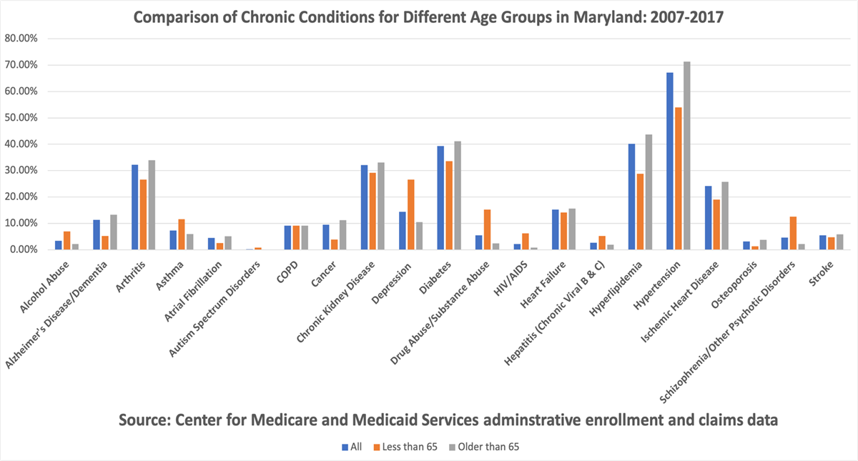
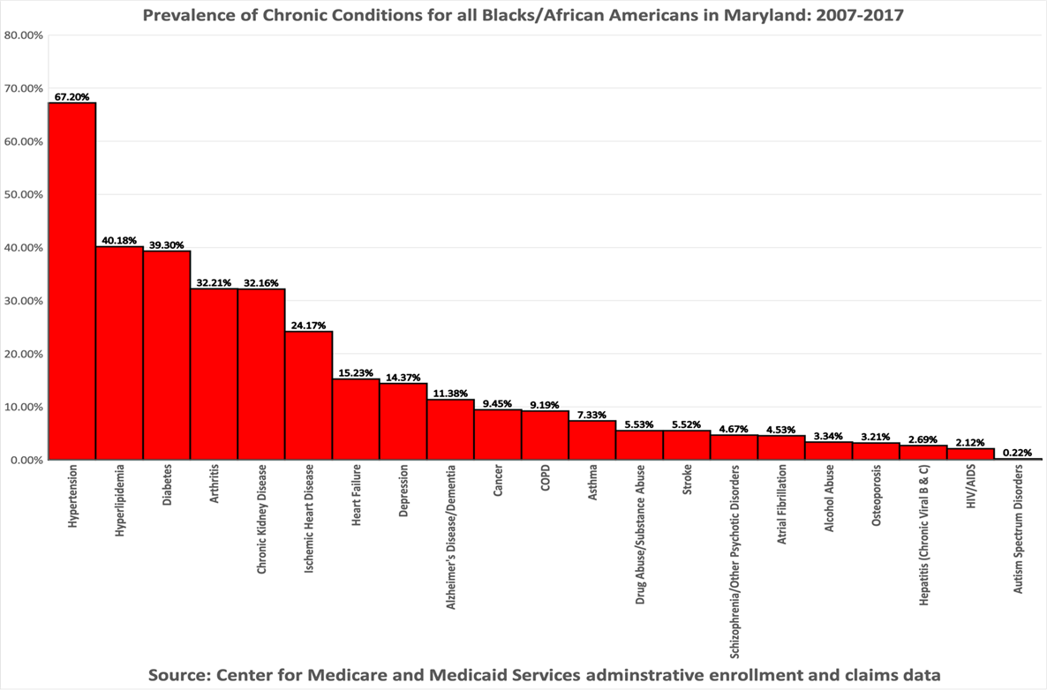
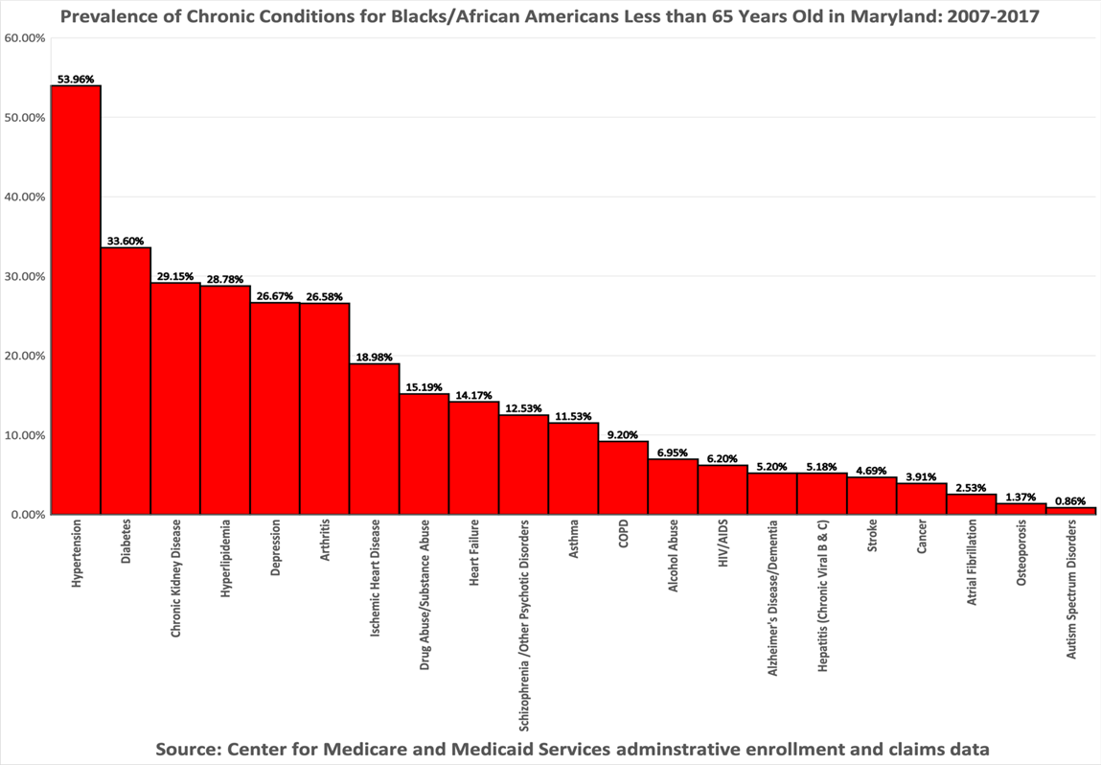

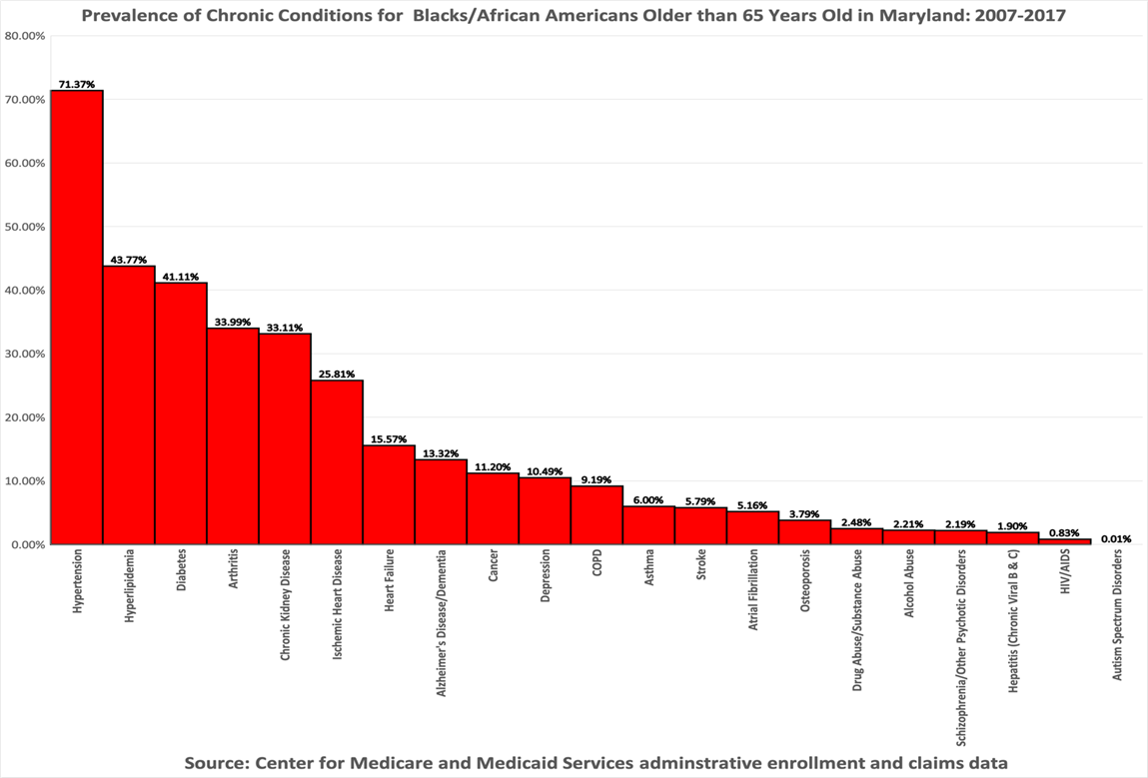
Planning and Administrative Activities
DATE | ACTIVITY | ACTION/NEXT STEPS
Continuously | Made contact to establish a Physician referral network, Pharmacies to drop off referrals, and order forms to offices. Creating a physician referral network for patients. System for tracking referrals | Contacted Dr. Kathryn Kelly, Dr. Jean Welsh, Dr. Ayim Djamsson, Dr. Ball (psychologist)
Implement a Strategic Action Plan (SAP) | Assign roles within the organization to both Outcomes and Marketing SAPs | Continue Monthly and Quarterly reporting
Plan to conduct monthly in-service for AAHP staff | Monthly in-service to give insight into the Chronic Disease Program to aid staff in the promotion of the program. Processes, procedures, Paperwork, oversight. | Continuous December 2020.
DPP, AHA, ADA, and AADE meetings and Accreditation and consulting | Continuing status of AAHP accreditation as a stand-alone AADE/ADA program and billing. Strategized program goals for future projects. Schedule AAHP Advisory board. | Continuous chart maintenance and documentation.  Advisory Board Meeting scheduled for TBD in December 2020.

SOCIAL WORK SERVICES

Mental Health Screenings
In November, AAHP’s mental health screening tools have been completed a total of 18 times. The link has accessed a total of 38 times, with a 47% completion rate. All screenings were completed either via desktop or phone devices (5 screenings via desktop and 13 screenings via phone increased slightly. This change may be due to a change in outreach this month, where a greater emphasis was put on in-person education of our screening device at locations such as food distribution sites. However, this may also have contributed to the increase in access, but a decline in completion where potential clients were able to view the tool in person. 100% of screeners identified as Black/African American. The results of November’s screenings are below:
  - 4 Wellbeing Screening
  - 4 Generalized Anxiety
  - 2 Wide Range Screenings
  - 2 HANDS Depression
  - 2 Bipolar
  - 1 Gambling Screening
  - 1 Substance Use Disorder
  - 1 PTSD
  - 1 Adolescent Depression

Mental Health Support
In November, AAHP’s social worker provided mental health support to three County residents on an ongoing basis. Of these, one client was interested in and sought a mental health provider for long-term support, and another inquired about the availability of services for a family member/loved one. The social worker was able to provide counsel, psychoeducation on symptom management, and resource assistance for these individuals, as well as follow up service. These clients continue to receive support for follow up care.

Community Outreach/ Collaboration
In November, AAHP’s social worker met with the American Muslim Senior Society stakeholders’ group to plan the upcoming Equity and Justice online forum tentatively scheduled for January 2021. The purpose of this collaboration is to expand the outreach of AAHP services to diverse African/African American groups in Montgomery County. She also participated in The Interagency Coalition on Pregnancy meeting to gather resources and program updates to be used to share with clients in need. Finally, she also led a discussion on the health benefits of nutritious and healthy eating, as well as the effects of food on mood and wellbeing with a group of approximately 20 individual Montgomery County parents in the Making Home Possible (MHP) program. Clients from this group have since been referred to other AAHP programs such as CDMP classes and the weight management program.

SMILE
AAHP’s social worker received seven referrals from SMILE nurses for clients and completed a total of 13 telephonic visits with clients in November. Similar to last month, these consultations focused on providing access to healthcare, food, and housing. Clients were reached through their preferred virtual methods (e.g., telephone or Facetime). All initial full phone contacts consisted of the completion of the Health-Related Social Needs screening tool developed by CMS. Other contacts included providing follow up support and monitoring progress for clients with individual/family goal plans. This process involves identifying and modifying the goal as needed, identifying obstacles and barriers to goal fulfillment, and assisting with problem-solving strategies. This has worked well with clients who find it difficult to create and manage goals alone, as well as for those who have little to no support in their personal lives.

SMILE Case Report
A critical case occurring in November involved a client experiencing unbearable tooth pain due to impacted wisdom teeth. This client received education from her nurse case manager on the importance of oral care during pregnancy and the changes she was expected to experience as a result. Unfortunately, this client did not qualify for traditional dental insurance and did not have the means to afford coverage on her own. The social worker received an urgent referral to address this issue as her nurse feared the pain and discomfort could potentially trigger premature labor and/or further stress and discomfort. After assisting the client in applying for Medicaid to ensure proper prenatal care, the social worker began to address her dental coverage needs. Dental coverage is not included for traditional Medicaid recipients in the state of Maryland, unlike in many other states, so the client believed she did not qualify. Fortunately, the social worker was able to educate this client about her right to access dental care due to her pregnancy status—which would qualify her for the Healthy Smiles program. The social worker worked diligently to locate a provider willing to care for this patient on short notice. Within the week, the client was referred to a dental office through SMILE. The social worker assisted with scheduling her appointment, and she was seen by the oral surgeon the following week for wisdom tooth extraction. Although this was an issue this client had dealt with for months before her enrollment, the SMILE team was able to resolve the situation swiftly and efficiently. Following the extraction, the client expressed great gratitude and relief. She is now continuing to be monitored by her nurse case manager and healing well from her surgery.

Trainings
The AAHP Social Worker participated in three Montgomery County DHHS Trainings in November: Critical Shared Decision Making as Ethical Practice (11/10/20), Sexuality & Dementia Issues for Older Adults (11/12/20), and Intersection of IPV & Stalking (11/18/20).

Social Work Referrals: Total (15)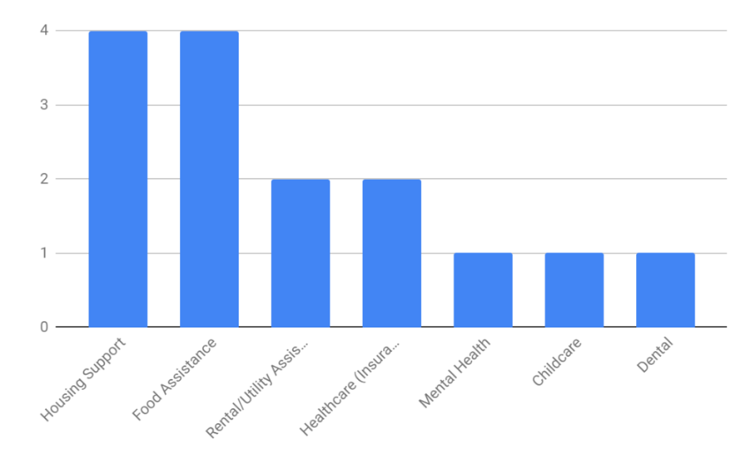

HIV/STI/AIDS Education

HIV Screenings
Despite the challenges posed by the pandemic, AAHP’s community health workers continued to safely provide health screening services to detect and monitor HIV/STIs among Black residents. AAHP staff continued HIV testing at the Dennis Avenue Health Center on Mondays, each week from 1 pm-3 pm. A total of 21 HIV tests were performed in November: 13 at Progress Place homeless shelter in downtown Silver Spring, three at the Health Department on Dennis Avenue in Silver Spring, and five at the AAHP office in Rockville. All results were negative. The table below documents the number of tests and participants.
Age Group | Male | Female
1947 -1969 | 5 | 1
1970 -1989 | 4 | 1
1990+ | 2 | 4
Total | 11 | 6 | 17
ALL OTHERS
 | Male | Female
1947 -1969 | 1 | 0
1970 -1989 | 2 | 1
1990+ | 0 | 0
Total | 3 | 1 | 4
GRAND TOTAL |  |  | 21

AAHP’s data coordinator used data from the Montgomery County HIV Epidemiological profile for FY2019 to create a map that depicts the distribution of HIV across the zip codes in Montgomery County. This map can be especially useful as we plan for HIV testing sites.

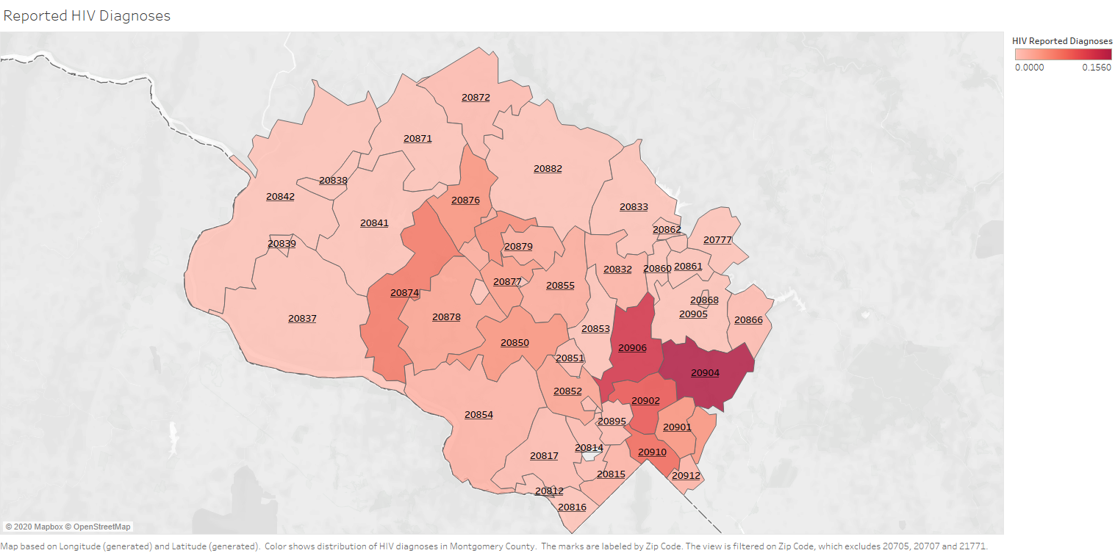

While conducting HIV testing and counseling for County residents, including homeless residents, staff also screened for hypertension, elevated HBA1c, and cholesterol. Also, staff distributed condoms and educational information and materials about health literacy and how to prevent the most common health conditions.

AAHP’s HIV Navigator also collaborated with DHHS Program Manager as a member of the Montgomery County Ending the HIV Epidemic (EHE) planning workgroup, which met twice in November to discuss ways to end HIV in Montgomery County and to prepare for World AIDS Day on December 1, when Montgomery County’s health officer will present the “Ending HIV Epidemic Program” plan for the next 5 years. During the working group meetings, AAHP’s HIV Navigator learned about the EHE vision of barrier-free access for people living with HIV and its mission to develop culturally informed, judgment-free HIV prevention/care.

Community Outreach
- AAHP Executive Committee COVID Testing Sites

Although McFarland and Associates are not involved in the actual COVID-19 testing at the AAHP Executive Committee test sites, it continues to respond to daily calls with additional questions about the testing process. AAHP staff also distributes programming and health information (on diabetes, weight management, heart disease, HIV, and sexual health) as well as AAHP masks, cups, pens, condoms, and bookmarks at different AAHP Executive Committee testing sites in Montgomery County.

- World Diabetes Day

AAHP successfully partnered with the Washington Midtown Lions club to host its first annual event, World Diabetes Day, on Saturday, Nov 14th, 10 am to 12 noon. Through this partnership, eight new clients joined our mailing list to volunteer for future outreach events and enroll in virtual CDMP classes.

- County Food Distribution Sites
AAHP continues to conduct community outreach at food distribution sites by providing gift bags and information about AAHP programs and services to Black residents in their cars as they wait to collect their groceries. In November, AAHP participated in successful food distribution events at People’s Community Church, Kings & Priest International Church, Oak Chapel Church, Kingdom Fellowship Church, the East County Regional Services Center, and several East County apartment complexes.

In November, AAHP staff began tracking encounters with individuals at food distribution sites to make follow-up calls to provide referrals to AAHP and other County-supported programs to connect Black and Latino residents to the resources they needed during the pandemic. The image below is an example of one of the detailed food distribution encounter tracking spreadsheets with identifying information removed.

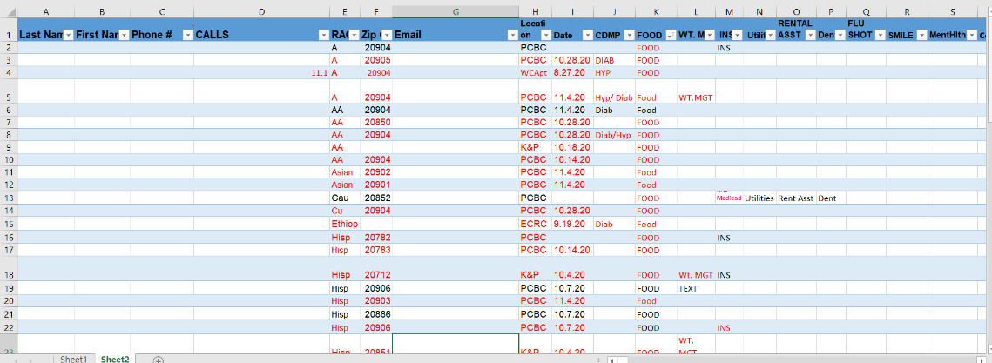
The chart below catalogs the items distributed at community outreach events. AAHP giveaway bags contained a combination of health information pamphlets (on diabetes, cancer, cholesterol, sexual health, weight management, and oral health), condoms, and water bottles.

 | Peoples Church | Kings & Priest | Other Events
Hypertension |  |  | 500
Hand Sanitizers | 50 | 50
HIV Epidemic | 50 | 50
Condoms | 300 | 300
HIV Testing Flyers | 25 | 25
Smile Brochure | 50 | 50
PrEP is for you Pamphlet | 50 | 50
HIV treatment Work Cards | 50 | 50
Diabetes | 80 | 80 | 700
STD Facts for teen Pamphlet | 50 | 50
COVID-19 Testing Sites |  |  | 150
Colorectal Cancer Booklet | 10 | 10
Mammogram Booklet | 20 | 20
Health Insurance |  |  | 150
Cancer Pamphlets (Men) | 15 | 15
Cancer Pamphlets Women | 10 | 10
Mental Health |  |  | 350
HIV- Get Tested | 50 | 50
Diabetes Pamphlets | 50 | 20 | 700
Cholesterol Pamphlets | 20 | 20
Youth and Sexual | 50 | 50
Weight Management | 50 | 50
AAHP Card | 100 | 100
African American Bags Given | 80 | 90
Others (Hispanics, Asians, Caucasians) | 90 | 40
Total of number of bags given | 170 | 130

Planning and Administrative Activities
- Meetings

AAHP staff continued to facilitate the execution of the monthly AAHP Executive Committee and Executive Coalition meetings by setting up Zoom functionality and transmitting announcements and links in advance of the meeting.

- Information System Use and Implementation
In November, AAHP staff completed the first series of SMILE education videos on breastfeeding, depression/stress management, newborn care, childbirth/recovery, preterm labor, and developmental milestones. All of the videos have been edited appropriately to make sure that they are ready for the public’s viewing. The staff works intently to assure that the content on slides is error-free before publishing the videos on the AAHP website.

- Management Information System
AAHP staff continued to enter case and patient data and refine elements of the AAHP case management system. Specifically, in November, the data coordinator focused on the SMILE reporting feature to ensure that it generated the appropriate data for the nurse case managers.

APPENDIX A
November 2020 Media Report

APPENDIX A
November 2020 Media Report

AAHP Health Notes - Distributed: Saturday, November 13, 1:30pm
November Campaign Metrics
 | November | October
General List Recipients: | 1643 | 1644
Successful deliveries: | 1277 | 1275
Open rate: | 15% | 19.3%
Click rate | 9.4% | 4.9%
Unsubscribed because of this message | 1 | 2

In recognition of American Diabetes month, AAHP’s November Health Notes feature story focused on AAHP’s Diabetes/Heart Health focus area which gives hope and resources to diabetics (and prediabetics) who wish to take control of their health by making positive lifestyle changes. This story included a Center for Disease Control and Prevention video on the new Diabetes Prevention Program (DPP) which helps pre-diabetic and at-risk participants adopt lifestyle changes that can help prevent Type 2 diabetes. The next article focused on lung cancer, particularly as it relates to African American men who have the highest rates of lung cancer in the U.S., with an incidence rate 30% higher than for White men. And the fact that both African American women and men are more likely to develop and die from lung cancer in spite of lower smoking rates and less exposure to cigarette smoke compared to White Americans. The next article focused on the physical and mental damage caused by stress and anxiety and some of the techniques to mitigate its effects in these challenging times. The next note shared information about the SMILE program’s series of videos and online tools on pregnancy, labor, breastfeeding, and more. Visit AAHP’s website to see the coming video series on pregnancy through the first year of life, the childhood development classes featuring presentations by SMILE nurse case managers, and the SMILE bucks participating moms can earn to cash in for giveaways and prizes like pacifiers, books, and car seats. The Health Hint provided creative ways to stay connected to loved ones over Thanksgiving despite social distancing. The featured video from TEDx explained the health benefits of yoga’s combination of movement and posture, breathing techniques, and spiritual contemplation. The featured recipe was Creamy Vegan Butternut Squash Pudding.

November’s Health Notes was opened by 193 readers, which represents a decrease of 57 readers from last month. The open rate of 15% was lower than last month’s open rate of 20%, lower than AAHP’s average of 22%, and on par with the industry average of 15%. November’s click rate of 9% was 4% higher than last month’s, slightly lower than AAHP’s average of 7%, and on par with the industry average of 9%. The bounce rate also remained the same. Unfortunately, one person unsubscribed.

AAHP Website
AAHP’s website continued to showcase more and more relevant and timely information in the News section, the Health Sciences Literature page, and the COVID-19 information page, which featured links to AAHP’s Executive Committee’s COVID-19 page at www.aahpcovid.com.

The following outlines the basic AAHP website metrics for November:
- 8,000 visits compared to 5,240 visits last month.
- 44% of visitors accessed AAHP’s website on their desktop computers, and 55% accessed the website on their phone or tablet.

Facebook
AAHP’s Facebook performed extremely well in November, with a significant increase in followers and impressions. Posts on AAHP’s health and fitness have performed especially well, with a video graphic for Zumba as the most popular post.

Facebook Metrics – November ‘20
 | Followers | Posts | Likes/Love | Comments | Shares | Impressions | Engagement Rate
Total | 689 | 16 | 29 | 0 | 15 | 1944 | 29
Change from last month | +22 | -20% | +19 | -1 | +1 | +20,52% | +20.83%

Twitter
AAHP’s Twitter performed well, with a significant number of new followers and mentions compared to last month. Additionally, the number of profile visits increased 453%.

Twitter Metrics – November ‘20
 | Followers | New Followers | Tweets | Profile Visits | Retweets | Mentions | Tweet Impressions
Total | 344 | 8 | 13 | 30 | 0 | 20 | 2318
Change from last month |  | +13 | +5 | +136 | -8 | +15 | +474

Instagram
AAHP’s Instagram channels continued to perform well. AAHP’s followers increased by 11 while Kickstart Your Health’s Instagram almost doubled the number of impressions compared to last month. The post featuring a strawberry salsa recipe was the most popular, with an engagement rate of 8%.

Instagram Metrics – November ‘20
 | Followers | Post Likes | Engagement Rate | Impressions | Reach
Total | 156 | 57 | 2% | 722 | 13
Change from last month | +11 | -60 | -2% | -174 | -7

 | Followers | Post Likes | Engagement Rate | Impressions | Reach
Total | 5 | 22 | 33.8% | 359 | 11
Change from last month | +0 | -33 | -33% | -174 | -7

LinkedIn
In November, AAHP began the process of adding LinkedIn to its current social media strategy with a focus on increasing the number of strategic collaborating and referral partnerships in the public health stakeholder community to expand the awareness, reach, and influence of AAHP programs. This strategy will involve regularly posting AAHP content, such as instructional videos, focus specific newsletters, and event information, and then promoting that content to position AAHP as a subject matter expert in the field of African American public health and to increase public awareness of its many lifesaving, health-advancing programs. To implement this strategy, Elisse Barnes, a LinkedIn trainer, will create and administer an AAHP company page on LinkedIn and train select AAHP staff members on how to leverage and grow their network to promote AAHP content. LinkedIn metrics will then be tracked along with those on Facebook, Instagram, and Twitter. Engagements begun online will be converted to Zoom conversations to form collaborating and referral partnerships which will also be tracked.

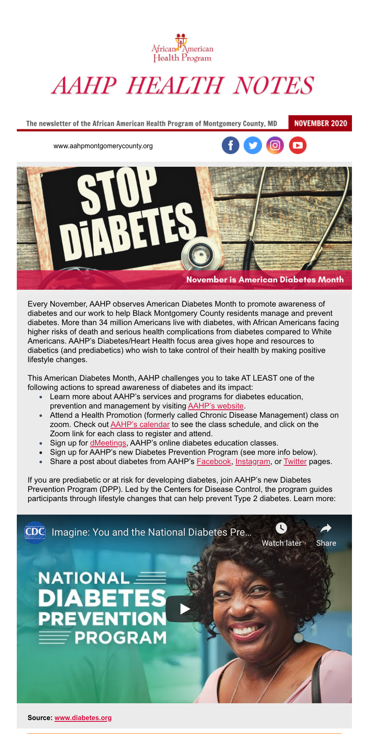
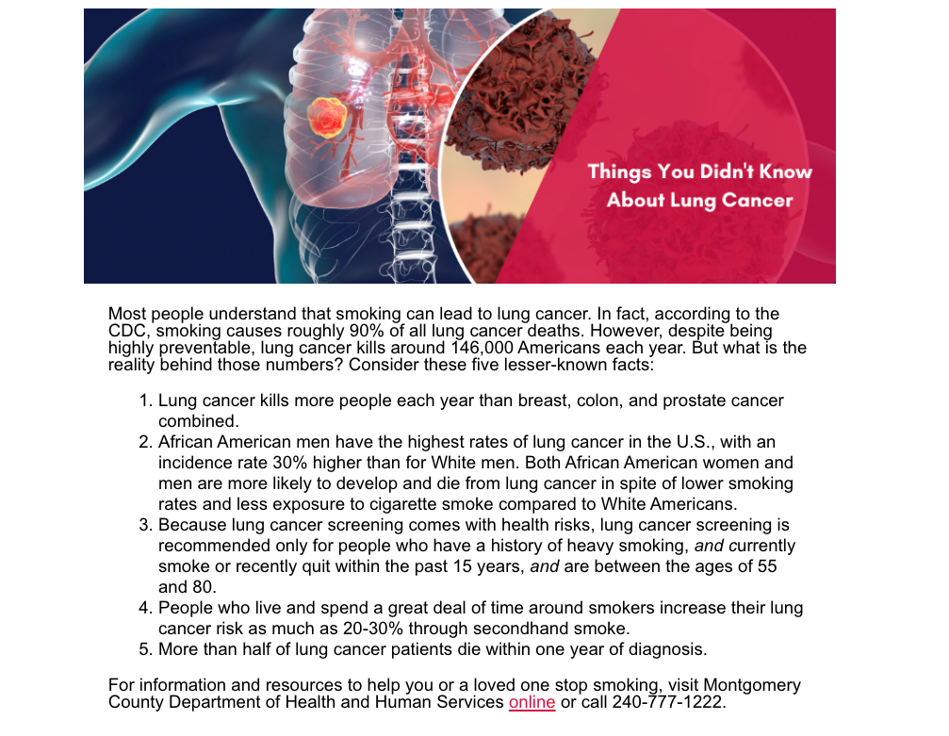

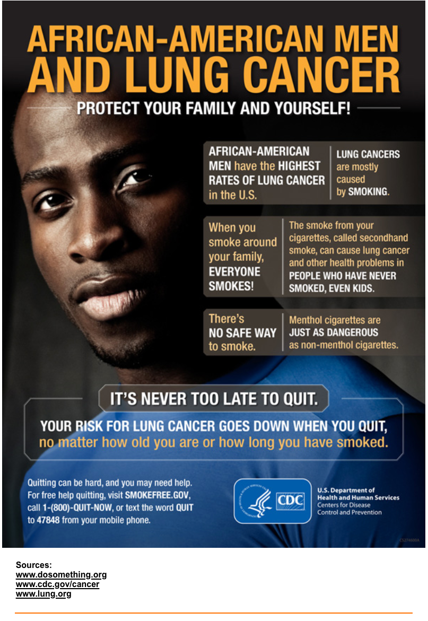
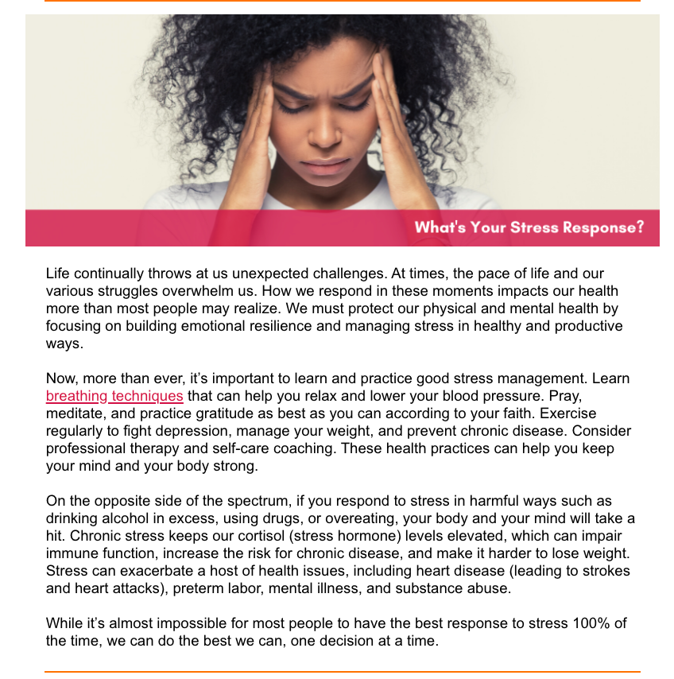

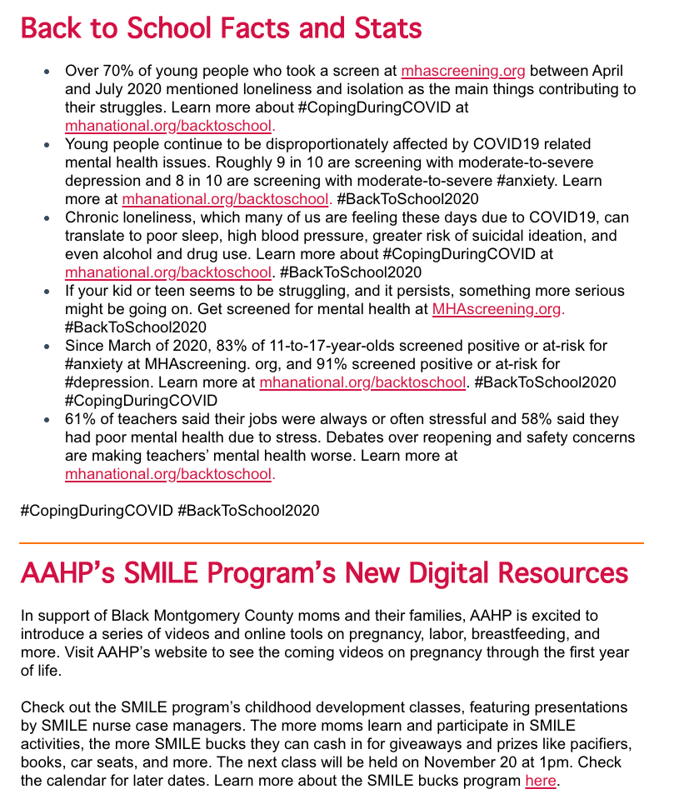

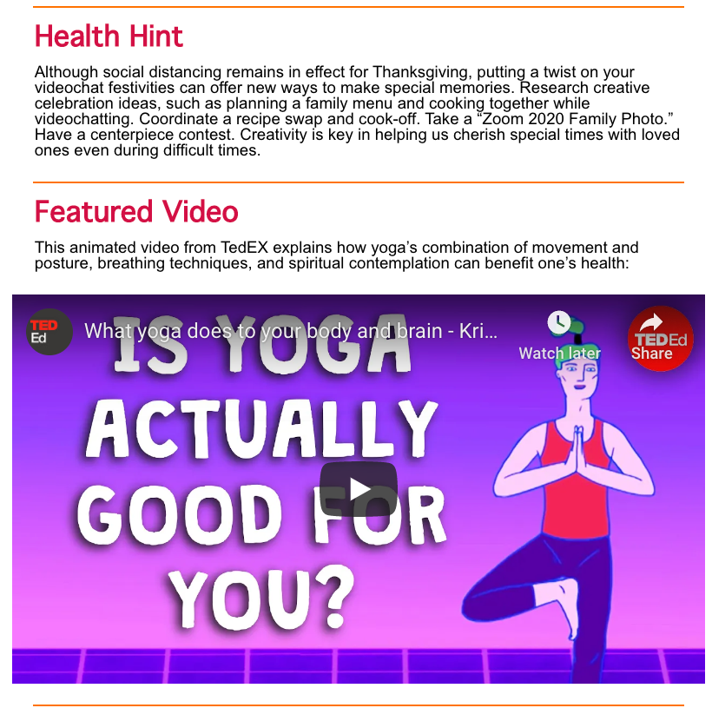
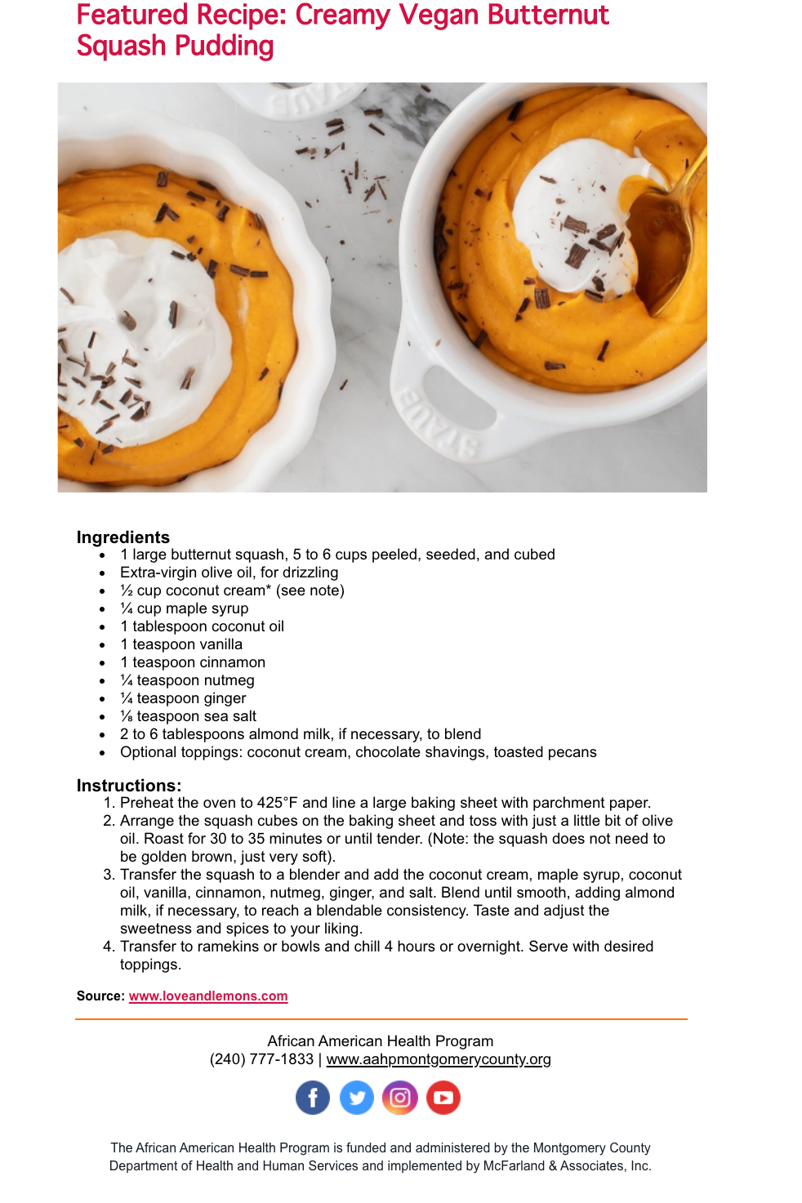
Facebook
AAHP’s Facebook page performed lower in November than September, yet the number of followers remained the same. Health and Fitness class posts performed well, particularly the Zumba online classes.

Facebook Metrics – November ‘20
 | Followers | Posts | Likes/Love | Comments | Shares | Impressions | Engagement Rate
Total | 667 | 21 | 10 | 1 | 14 | 1318 | 25
Change from last month | same | -30% | -28 | -1 | -14 | -28.33% | -63%

Twitter
AAHP’s Twitter performed well, with a significant number of mentions and retweets compared to last month.

Twitter Metrics – November ‘20
 | Followers | New Followers | Tweets | Profile Visits | Retweets | Mentions | Tweet Impressions
Total | 331 | 8 | 8 | 30 | 8 | 5 | 1844
Change from last month |  | +1 | -13 | -28 | +7 | +4 | -2618

Instagram
AAHP’s Instagram channel continued to perform well, with a slight increase in the number of followers. Most notably, posts garnered a significant increase in the number of likes compared to last month.

Instagram Metrics – November ‘20
 | Followers | Post Likes | Engagement Rate | Impressions | Reach
Total | 145 | 135 | 4% | 896 | 21
Change from last month | 2 | +86 | -2% | -252 | -1

LinkedIn
In November, AAHP began the process of adding LinkedIn to its current social media strategy with a focus on increasing the number of strategic collaborating and referral partnerships in the public health stakeholder community to expand the awareness, reach, and influence of AAHP programs. This strategy will involve regularly posting AAHP content, such as instructional videos, focus specific newsletters, and event information, and then promoting that content to position AAHP as a subject matter expert in the field of African American public health and to increase public awareness of its many lifesaving, health-advancing programs. To implement this strategy, Elisse Barnes, who is a LinkedIn trainer, will create and administer an AAHP company page on LinkedIn and train select AAHP staff members on how to leverage and grow their network to promote AAHP content. LinkedIn metrics will then be tracked along with those on Facebook, Instagram, and Twitter. Engagements begun online will be converted to Zoom conversations to form collaborating and referral partnerships which will also be tracked.

APPENDIX B
November 2020 Health Notes

AAHP Health Notes - Distributed:
November Campaign Metrics
 | November | October
General List Recipients: |  | 1644
Successful deliveries: |  | 1275
Open rate: |  | 19%
Click rate |  | 5%
Unsubscribed because of this message |  | 2

In recognition of American Diabetes month, AAHP’s November Health Notes feature story focused on AAHP’s Diabetes/Heart Health focus area which gives hope and resources to diabetics (and prediabetics) who wish to take control of their health by making positive lifestyle changes. This story included a Center for Disease Control and Prevention video on the new Diabetes Prevention Program (DPP) which helps pre-diabetic and at-risk participants adopt lifestyle changes that can help prevent Type 2 diabetes. The next article focused on lung cancer, particularly as it relates to African American men who have the highest rates of lung cancer in the U.S., with an incidence rate 30% higher than for White men. And that fact that both African American women and men are more likely to develop and die from lung cancer in spite of lower smoking rates and less exposure to cigarette smoke compared to White Americans. The next article focused on the physical and mental damage caused by stress and anxiety and some of the techniques to mitigate its effects in these challenging times. The next note shared information about the SMILE program’s a series of videos and online tools on pregnancy, labor, breastfeeding, and more. Visit AAHP’s website to see the coming video series on pregnancy through the first year of life, the childhood development classes featuring presentations by SMILE nurse case managers, and the SMILE bucks participating moms can earn to cash in for giveaways and prizes like pacifiers, books, and car seats. The Health Hint provided creative ways to stay connected to loved ones over Thanksgiving despite social distancing. The featured video from TEDx explained the health benefits of yoga’s combination of movement and posture, breathing techniques, and spiritual contemplation. The featured recipe was Creamy Vegan Butternut Squash Pudding.

November’s Health Notes was opened by readers. The open rate of 19.3% remained on par with last month’s rate, which is lower than AAHP’s average, and 4% higher than the industry average. November’s click rate of. The bounce rate. There were unsubscribes.

